PL SQL Programming

**Exercise 3: Stored Procedures**

**Scenario 1:** The bank needs to process monthly interest for all savings accounts.

* + **Question:** Write a stored procedure **ProcessMonthlyInterest** that calculates and updates the balance of all savings accounts by applying an interest rate of 1% to the current balance.

**Scenario 2:** The bank wants to implement a bonus scheme for employees based on their performance.

* + **Question:** Write a stored procedure **UpdateEmployeeBonus** that updates the salary of employees in a given department by adding a bonus percentage passed as a parameter.

**Scenario 3:** Customers should be able to transfer funds between their accounts.

* + **Question:** Write a stored procedure **TransferFunds** that transfers a specified amount from one account to another, checking that the source account has sufficient balance before making the transfer.

QUERY:

CREATE TABLE accounts (

account_id NUMBER PRIMARY KEY,

customer_id NUMBER,

account_type VARCHAR2(20),

balance NUMBER

);

CREATE TABLE employees (

emp_id NUMBER PRIMARY KEY,

emp_name VARCHAR2(50),

salary NUMBER,

department_id NUMBER

);

INSERT INTO accounts VALUES (101, 1, 'SAVINGS', 10000);

INSERT INTO accounts VALUES (102, 1, 'CURRENT', 5000);

INSERT INTO accounts VALUES (103, 2, 'SAVINGS', 20000);

INSERT INTO accounts VALUES (104, 3, 'CURRENT', 7000);

INSERT INTO employees VALUES (1, 'Alice', 30000, 10);

INSERT INTO employees VALUES (2, 'Bob', 25000, 20);

INSERT INTO employees VALUES (3, 'Charlie', 22000, 10);

INSERT INTO employees VALUES (4, 'Diana', 27000, 30);

COMMIT;

SCENARIO 1:

**Scenario 1:** The bank needs to process monthly interest for all savings accounts.

* + **Question:** Write a stored procedure **ProcessMonthlyInterest** that calculates and updates the balance of all savings accounts by applying an interest rate of 1% to the current balance.

QUERY:

CREATE OR REPLACE PROCEDURE ProcessMonthlyInterest AS

BEGIN

UPDATE accounts

SET balance = balance + (balance * 0.01)

WHERE account_type = 'SAVINGS';

COMMIT;

END;

/

OUTPUT:

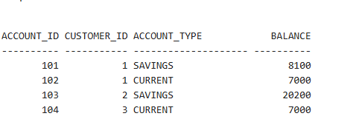

SCENARIO 2:

**Scenario 2:** The bank wants to implement a bonus scheme for employees based on their performance.

* + **Question:** Write a stored procedure **UpdateEmployeeBonus** that updates the salary of employees in a given department by adding a bonus percentage passed as a parameter.

QUERY:

CREATE OR REPLACE PROCEDURE UpdateEmployeeBonus(

p_dept_id IN NUMBER,

p_bonus_percent IN NUMBER

) AS

BEGIN

UPDATE employees

SET salary = salary + (salary * p_bonus_percent / 100)

WHERE department_id = p_dept_id;

COMMIT;

END;

/

OUTPUT:

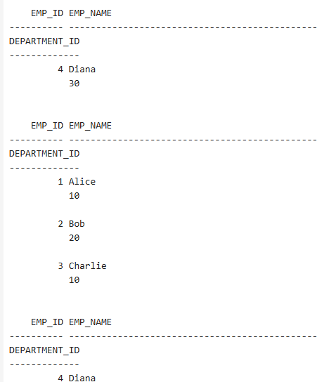

SCENARIO 3:

**Scenario 3:** Customers should be able to transfer funds between their accounts.

* + **Question:** Write a stored procedure **TransferFunds** that transfers a specified amount from one account to another, checking that the source account has sufficient balance before making the transfer.

QUERY:

CREATE OR REPLACE PROCEDURE TransferFunds(

p_from_account IN NUMBER,

p_to_account IN NUMBER,

p_amount IN NUMBER

) AS

v_balance NUMBER;

BEGIN

SELECT balance INTO v_balance FROM accounts WHERE account_id = p_from_account FOR UPDATE;

IF v_balance >= p_amount THEN

UPDATE accounts

SET balance = balance - p_amount

WHERE account_id = p_from_account;

UPDATE accounts

SET balance = balance + p_amount

WHERE account_id = p_to_account;

COMMIT;

ELSE

RAISE_APPLICATION_ERROR(-20001, 'Insufficient balance');

END IF;

END;

/

BEGIN

ProcessMonthlyInterest;

END;

/

BEGIN

UpdateEmployeeBonus(10, 10);

END;

/

BEGIN

TransferFunds(101, 102, 2000);

END;

/

SELECT * FROM accounts;

SELECT * FROM employees;

OUTPUT:

